05th October 2017

**YOKOHAMA to supply tyres for 64th Macau Grand Prix**

YOKOHAMA will supply “ADVAN” racing tyres to the 64th Macau Grand Prix, to be held in Macau (China) 16th –19th November. YOKOHAMA supplied tyres for this event for 33 straight years until 2015. This year marks the 34th time the Company will support the Macau Grand Prix. YOKOHAMA tyres will be the control tyre for the event’s main race, the FIA F3 World Cup, and for the FIA World Touring Car Championship (WTCC) race. In addition, they will be the tyre of choice for many cars competing in the event’s support races.

The Macau Grand Prix, run on public roads in the city center, is one of the world’s most famous road races. Last year, the main F3 Grand Prix race was designated an official FIA world championship race and renamed the FIA F3 World Cup. YOKOHAMA began supplying control tyres for the race in 1983, when Formula 3 vehicles meeting international standards began competing in the event. Because the race is held on public roadways, participating vehicles require tyres that provide high performance on surfaces and conditions typical of normal driving conditions, which are quite different from those found on circuit racetracks. The F3 race has been won by many F1 racing greats, including Michael Schumacher in 1990 and Takuma Sato in 2001.

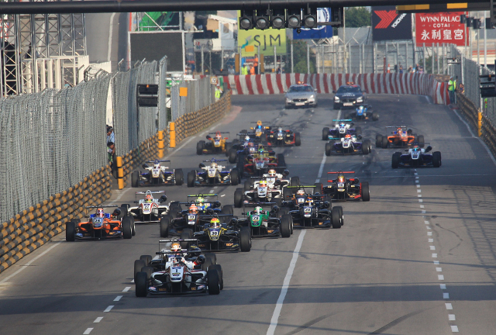

*Macau Formula 3 (2015)*